Loss Functions

When working on a Machine Learning or a Deep Learning Problem, loss/cost functions are used to optimize the model during training. The objective is almost always to minimize the loss function. The lower the loss the better the model. Cross-Entropy loss is a most important cost function. It is used to optimize classification models. The understanding of Cross-Entropy is pegged on understanding of Softmax activation function.
Consider a 4-class classification task where an image is classified as either a dog, cat, horse or cheetah.
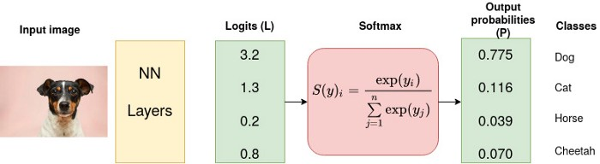
In the above Figure, Softmax converts logits into probabilities. The purpose of the Cross-Entropy is to take the output probabilities (P) and measure the distance from the truth values (as shown in Figure below).
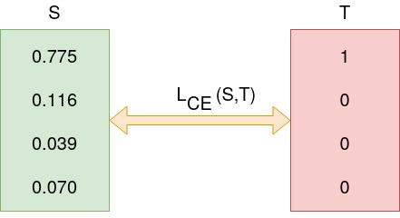
Cross Entropy (L) (Source: Author).
For the example above the desired output is [1,0,0,0] for the class dog but the model outputs [0.775, 0.116, 0.039, 0.070] .
The objective is to make the model output be as close as possible to the desired output (truth values). During model training, the model weights are iteratively adjusted accordingly with the aim of minimizing the Cross-Entropy loss. The process of adjusting the weights is what defines model training and as the model keeps training and the loss is getting minimized, we say that the model is learning.

Entropy
Entropy of a random variable X is the level of uncertainty inherent in the variables possible outcome.
For p(x) — probability distribution and a random variable X, entropy is defined as follows
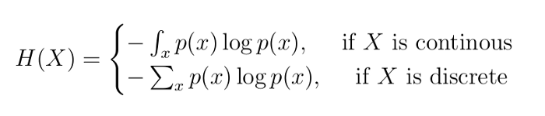

Reason for negative sign: log(p(x))<0 for all p(x) in (0,1) . p(x) is a probability distribution and therefore the values must range between 0 and 1.
The greater the value of entropy,H(x) , the greater the uncertainty for probability distribution and the smaller the value the less the uncertainty.
Example
Consider the following 3 “containers” with shapes: triangles and circles

3 containers with triangle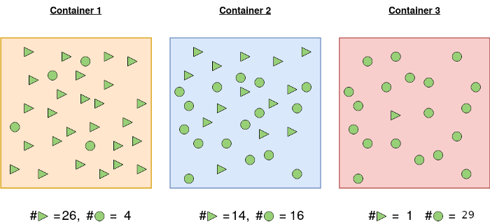 and circle shapes.
Container 1: The probability of picking a triangle is 26/30 and the probability of picking a circle is 4/30. For this reason, the probability of picking one shape and/or not picking another is more certain.
Container 2: Probability of picking the a triangular shape is 14/30 and 16/30 otherwise. There is almost 50–50 chance of picking any particular shape. Less certainty of picking a given shape than in 1.
Container 3: A shape picked from container 3 is highly likely to be a circle. Probability of picking a circle is 29/30 and the probability of picking a triangle is 1/30. It is highly certain than the shape picked will be circle.
Let us calculate the entropy so that we ascertain our assertions about the certainty of picking a given shape.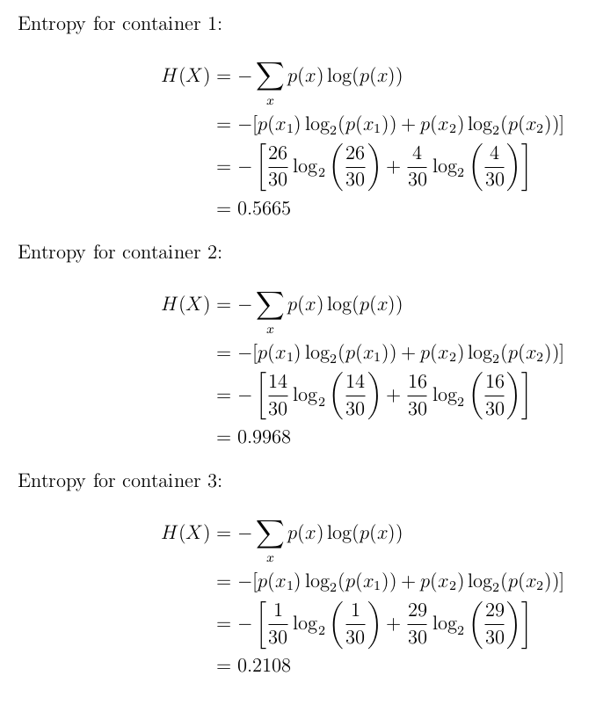
As expected the entropy for the first and third container is smaller than the second one. This is because probability of picking a given shape is more certain in container 1 and 3 than in 2.
Cross-Entropy Loss Function
Also called logarithmic loss, log loss or logistic loss. Each predicted class probability is compared to the actual class desired output 0 or 1 and a score/loss is calculated that penalizes the probability based on how far it is from the actual expected value. Cross-entropy loss is used when adjusting model weights during training. The aim is to minimize the loss, i.e, the smaller the loss the better the model. A perfect model has a cross-entropy loss of 0.
Cross-entropy is defined as
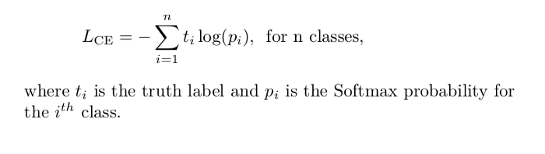
GANs try to replicate a probability distribution. They should therefore use loss functions that reflect the distance between the distribution of the data generated by the GAN and the distribution of the real data.
How do you capture the difference between two distributions in GAN loss functions? Two common GAN loss functions:
- Minimax loss:
- Wasserstein loss:
One Loss Function or Two?
A GAN can have two loss functions: one for generator training and one for discriminator training. How can two loss functions work together to reflect a distance measure between probability distributions?
In the loss schemes, the generator and discriminator losses derive from a single measure of distance between probability distributions. In both of these schemes, however, the generator can only affect one term in the distance measure: the term that reflects the distribution of the fake data. So during generator training we drop the other term, which reflects the distribution of the real data.
The generator and discriminator losses look different in the end, even though they derive from a single formula.

Minimax Loss
In the paper that introduced GANs, the generator tries to minimize the following function while the discriminator tries to maximize it:
Ex[log(D(x))]+Ez[log(1−D(G(z)))]
In this function:
- D(x) is the discriminator's estimate of the probability that real data instance x is real.
- E_{x} is the expected value over all real data instances.
- G(z) is the generator's output when given noise z.
- D(G(z)) is the discriminator's estimate of the probability that a fake instance is real.
- E_{z} is the expected value over all random inputs to the generator (in effect, the expected value over all generated fake instances G(z)).
- The formula derives from the cross-entropy between the real and generated distributions.
The generator can't directly affect the log(D(x)) term in the function, so, for the generator, minimizing the loss is equivalent to minimizing log(1 - D(G(z))).

Modified Minimax Loss
The above minimax loss function can cause the GAN to get stuck in the early stages of GAN training when the discriminator's job is very easy. Hence suggests modifying the generator loss so that the generator tries to maximize log D(G(z)).

Wasserstein Loss
This loss function depends on a modification of the GAN scheme (called "Wasserstein GAN" or "WGAN") in which the discriminator does not actually classify instances. For each instance it outputs a number. This number does not have to be less than one or greater than 0, so we can't use 0.5 as a threshold to decide whether an instance is real or fake. Discriminator training just tries to make the output bigger for real instances than for fake instances.
Because it can't really discriminate between real and fake, the WGAN discriminator is actually called a "critic" instead of a "discriminator". The loss functions themselves are deceptively simple:
Critic Loss: D(x) - D(G(z))
The discriminator tries to maximize this function. In other words, it tries to maximize the difference between its output on real instances and its output on fake instances.
Generator Loss: D(G(z))
The generator tries to maximize this function. In other words, It tries to maximize the discriminator's output for its fake instances.
In these functions:
- D(x) is the critic's output for a real instance.
- G(z) is the generator's output when given noise z.
- D(G(z)) is the critic's output for a fake instance.
- The output of critic D does not have to be between 1 and 0.

Challenges with GANs
The most important roadblock while training a GAN is stability. If you start to train a GAN, and the discriminator part is much powerful that its generator counterpart, the generator would fail to train effectively. This will in turn affect training of your GAN. On the other hand, if the discriminator is too lenient; it would let literally any image be generated. And this will mean that your GAN is useless.
Another way to glance at stability of GAN is to look as a holistic convergence problem. Both generator and discriminator are fighting against each other to get one step ahead of the other. Also, they are dependent on each other for efficient training. If one of them fails, the whole system fails. So you have to make sure they don’t explode.
- Problem with Counting: GANs fail to differentiate how many of a particular object should occur at a location. As we can see below, it gives more number of eyes in the head than naturally present.
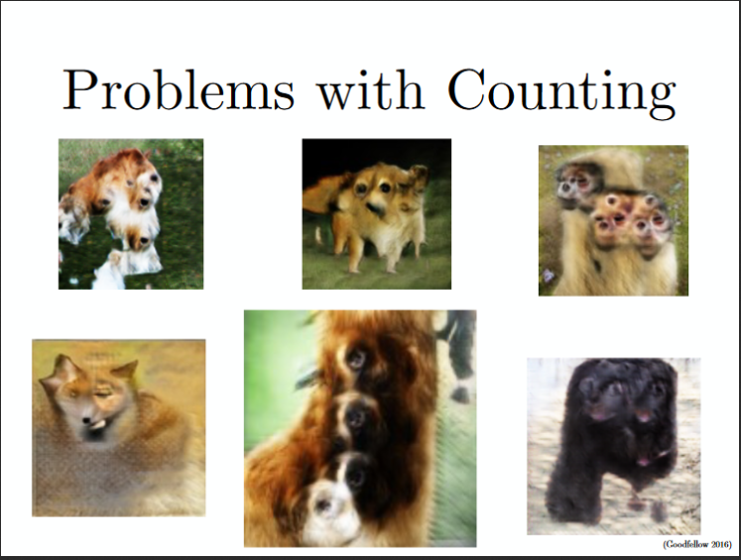
- Problems with Perspective: GANs fail to adapt to 3D objects. It doesn’t understand perspective, i.e. difference between front view and back view. As we can see below, it gives flat (2D) representation of 3D objects.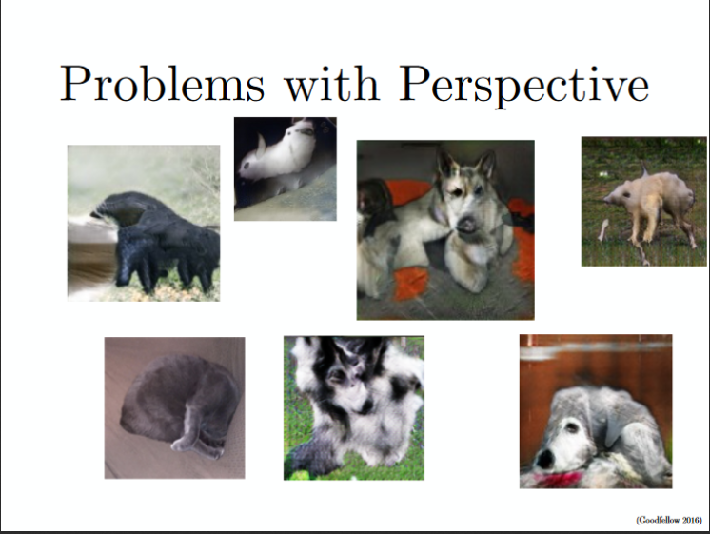
- Problems with Global Structures: Same as the problem with perspective, GANs do not understand a holistic structure. For example, in the bottom left image, it gives a generated image of a quadruple cow, i.e. a cow standing on its hind legs and simultaneously on all four legs. That is definitely not possible in real life!
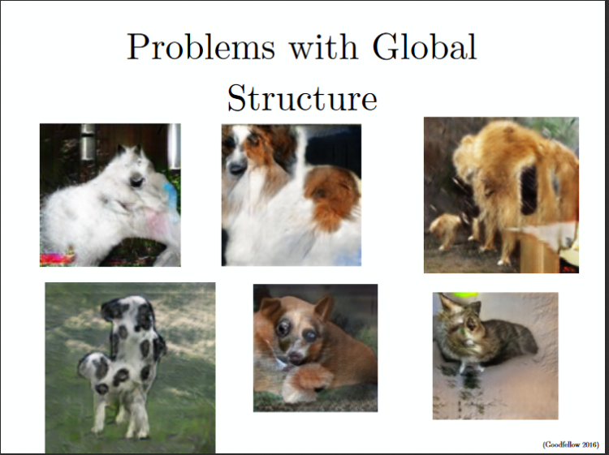
A substantial research is being done to take care of these problems. Newer types of models are proposed which give more accurate results than previous techniques, such as DCGAN, WassersteinGAN etc

